**Website Design for OU Events**

1. **Modification of main animation on homepage**

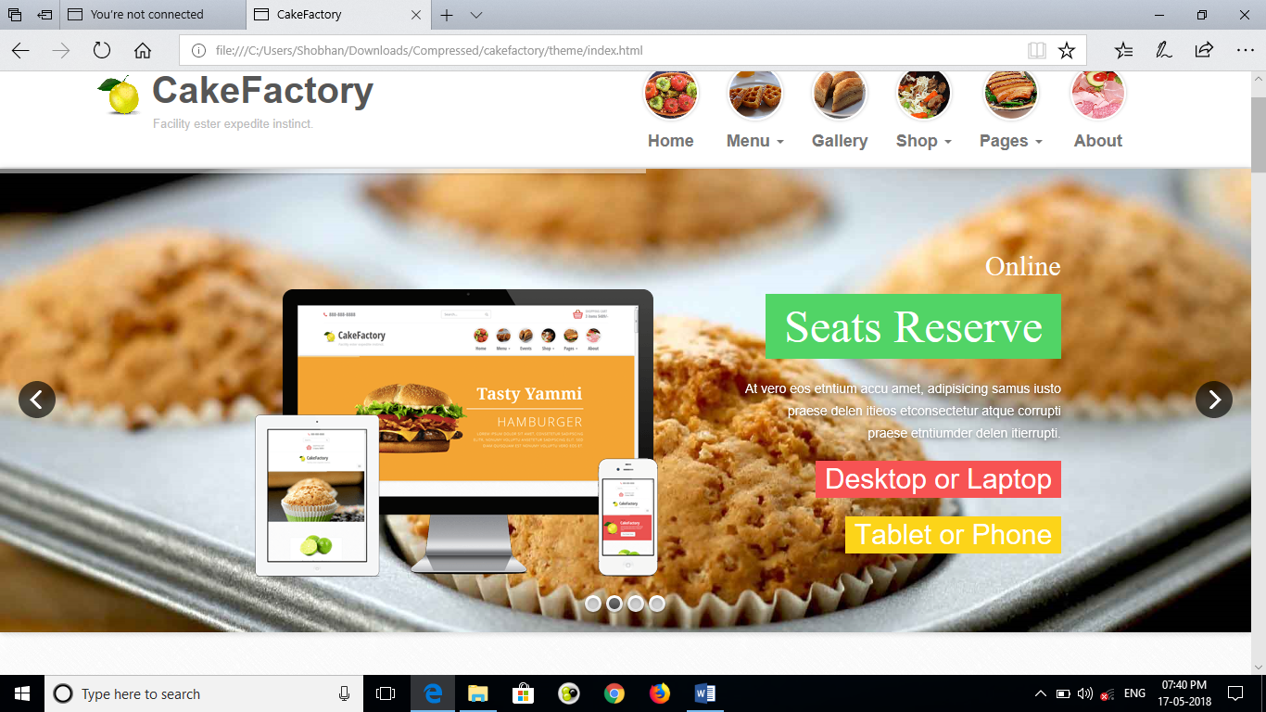

Instead of food items in the animation, it should be replace with event related pic and our offers

partner resturant logo can be used

2.**Modification of menu option**

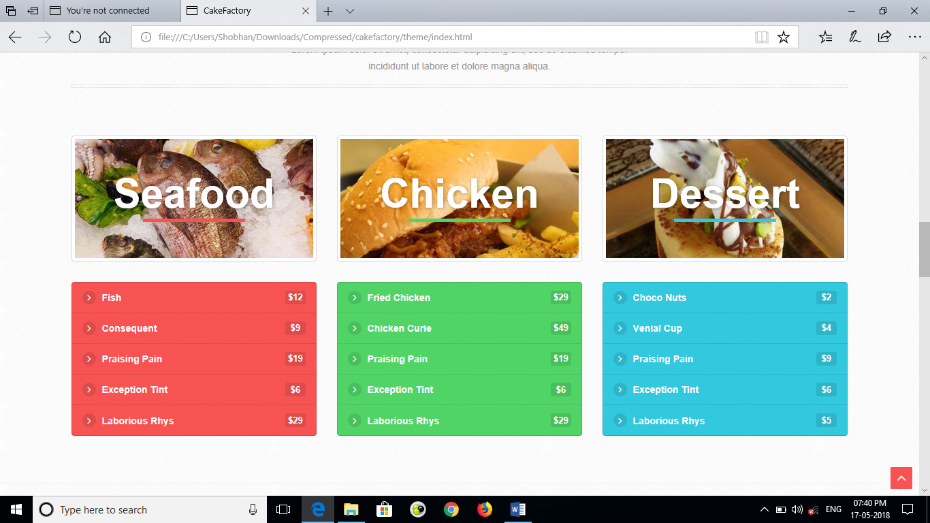

the menu part will be completely replace with RESTAURANT , VENUE, CATERER, DECORATOR,DJ,PHOTOGRAPHER (refer oyorooms.com the box they use for oyofor business and like that)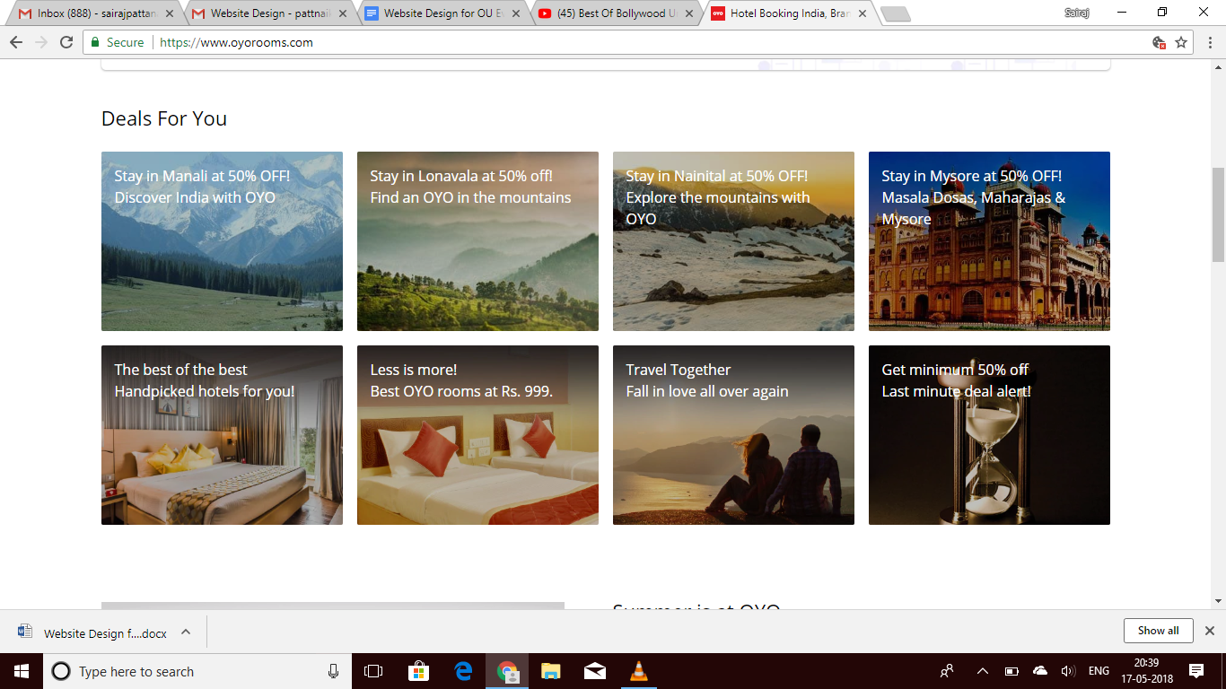

when one clicks restaurants -> it will direct to another page with lists of restaurant -> and when they select restaurant then they will be able to choose the menu for preorder or book a table

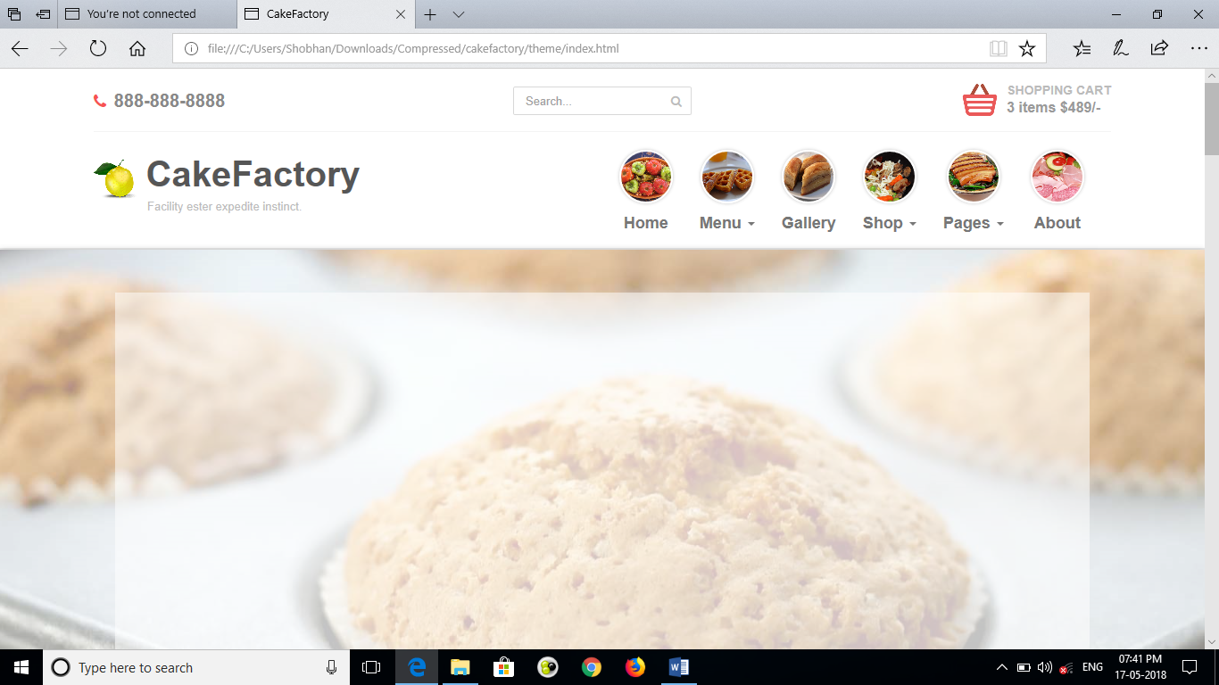

1. **Offers details in the offer price**

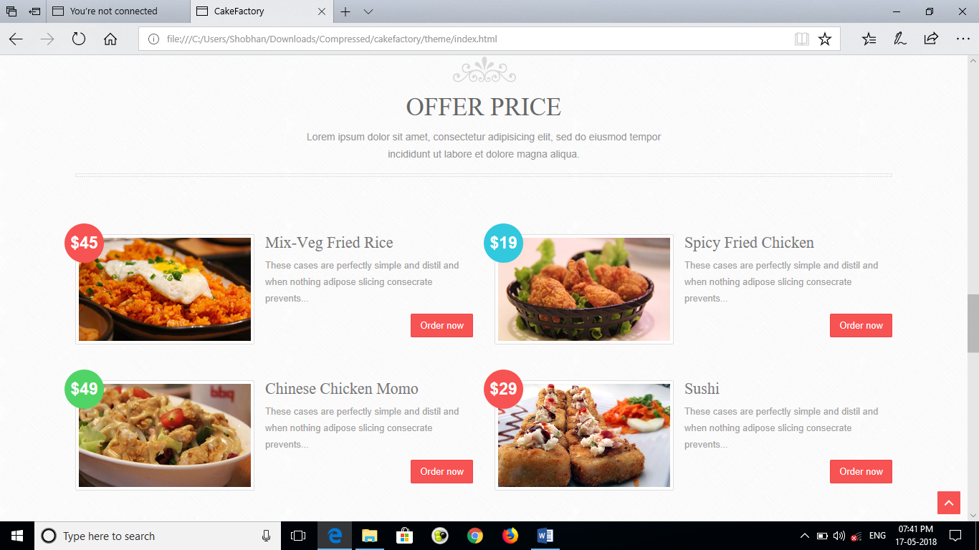

Instead of offer price, there should be starred offer details on our partner restaurants/decorator/venue and all other partner.. and click on Order now, it should redirect to menu option as mentioned above of that particular restaurant.

1. **Our team**

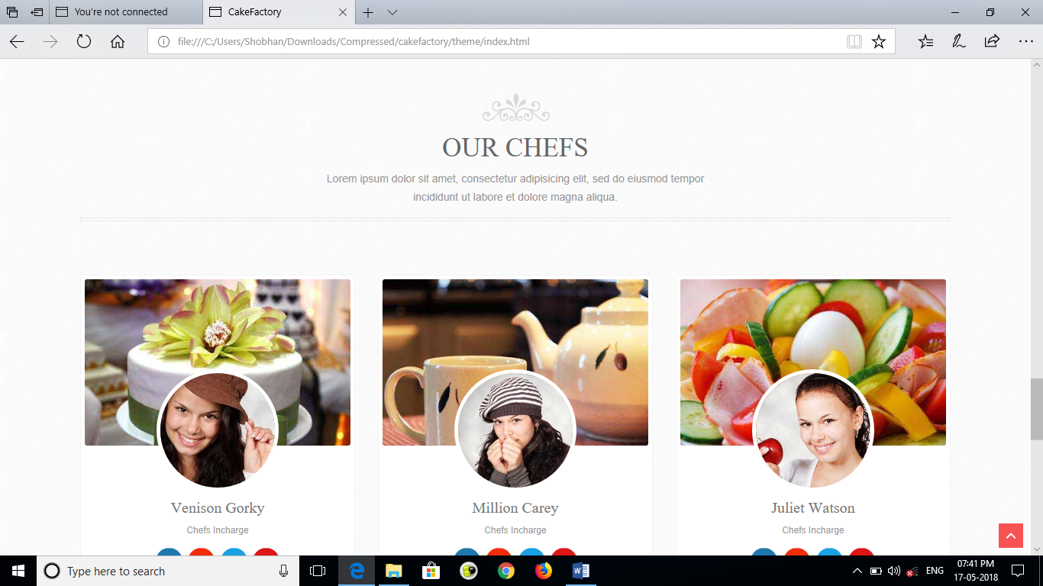make this area for testimonial we can use this for feedback from our valuable customers

1. **Updating of Contact details.**

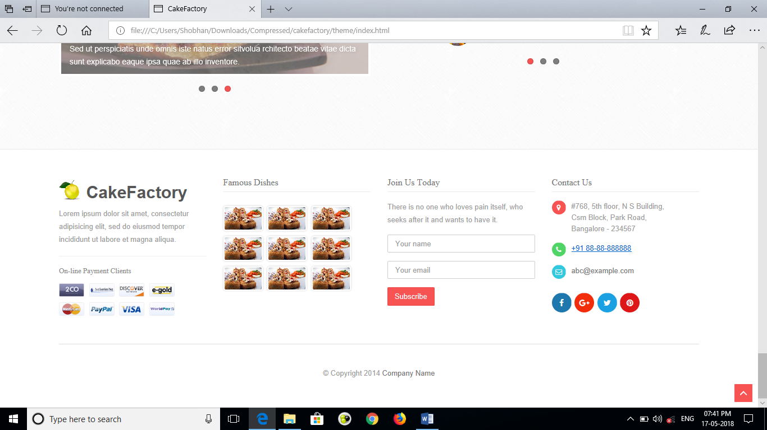

Instead of Join Us Today, we should have that ‘We are hiring ‘, so as to attract prospective employees. There should an attachment option as to attach the CV under ‘Your Email’ blank.

The Contact details should be updated as per requirement. In place of famous dishes, it should contain photo of our recent events.

Phase -2(Brief)

1. Making a login page for our partners

In the login page, our partner restaurant can see their bookings and their past transactions. There would be also an option to update their menu.

1. Making an admin page to check the outstanding payments from the partner restaurants.

Self-Explanatory

1. Integration of Facebook, Gmail login so as to authenticate that the user is a human
2. Adding payment gateway to pay the advance amount.

try to make the page of red colour as our company’s theme colour is red ..